**CODE:-**

#include <iostream>

using namespace std;

template <class T>

void my_swap(T &a, T &b)

{

T temp;

temp = a;

a = b;

b = temp;

}

int main()

{

int i1 = 5, i2 = 10;

cout << "For int." << endl;

cout << "i1= " << i1 << " i2= " << i2 << endl;

my_swap(i1, i2);

cout << "i1= " << i1 << " i2= " << i2 << endl;

float f1 = 5.5, f2 = 10.56;

cout << "For float." << endl;

cout << "f1= " << f1 << " f2= " << f2 << endl;

my_swap(f1, f2);

cout << "f1= " << f1 << " f2= " << f2 << endl;

char c1 = 'a', c2 = 'b';

cout << "For char." << endl;

cout << "c1= " << c1 << " c2= " << c2 << endl;

my_swap(c1, c2);

cout << "c1= " << c1 << " c2= " << c2 << endl;

return 0;

}

**OUTPUT:-**

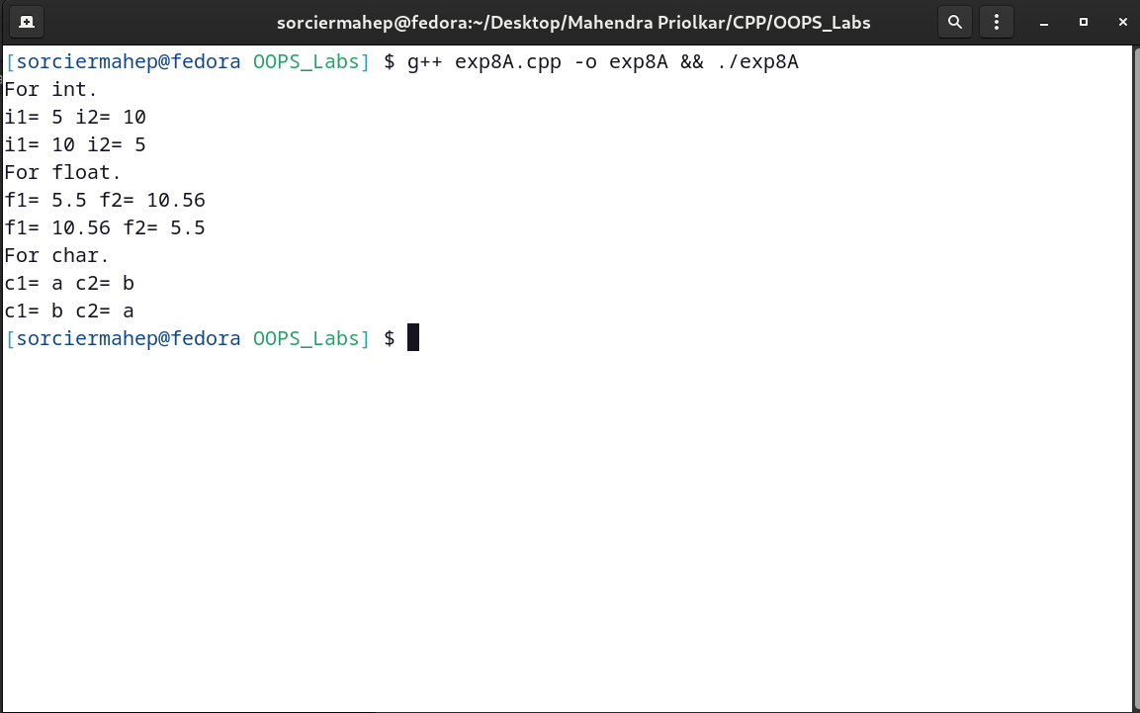

**CODE:-**

#include <iostream>

using namespace std;

template <class T>

class vector

{

int n;

public:

void getsize()

{

cout << "Enter size." << endl;

cin >> n;

}

private:

T *A = new T(n);

public:

void getelem()

{

cout << "Enter the elements of the vector." << endl;

for (int i = 0; i < n; i++)

cin >> *(A + i);

}

void display()

{

for (int i = 0; i < n; i++)

cout << *(A + i) << " ";

cout << endl;

}

void modify(int m)

{

T temp;

if (m > 0)

{

cout << "Enter the element to replace the current one." << endl;

cin >> temp;

*(A + m - 1) = temp;

}

}

};

int main()

{

vector<int> v1;

vector<float> v2;

vector<char> v3;

int m;

cout << "Int vector." << endl;

v1.getsize();

v1.getelem();

cout << "Original values." << endl;

v1.display();

cout << "Enter value of position which is to be changed(<1 no change)." << endl;

cin >> m;

v1.modify(m);

cout << "Changed values." << endl;

v1.display();

cout << "Float vector" << endl;

v2.getsize();

v2.getelem();

cout << "Original values." << endl;

v2.display();

cout << "Enter value of position which is to be changed(<1 no change)." << endl;

cin >> m;

v2.modify(m);

cout << "Changed values." << endl;

v2.display();

cout << "Char vector" << endl;

v3.getsize();

v3.getelem();

cout << "Original values." << endl;

v3.display();

cout << "Enter value of position which is to be changed(<1 no change)." << endl;

cin >> m;

v3.modify(m);

cout << "Changed values." << endl;

v3.display();

return 0;

}

**OUTPUT:-**

